NAME : Sankalp Vilas Rode

CLASS : Second Year

DIV : SY-B

ROLL NO.: 66

AIM :To study and understand Version Control using Git and GitHub, and perform basic operations like adding, committing, and pushing files to a repository.
Theory
Version Control System (VCS) is used to track changes in files and manage different versions of a project. It helps multiple developers work together efficiently. Git is a distributed version control system that tracks changes locally on your system. GitHub is a cloud-based platform that hosts Git repositories and allows collaboration. Basic workflow in Git: • Create repository • Add files • Stage files (git add) • Commit changes (git commit) • Push to remote repository (git push) Screenshots:

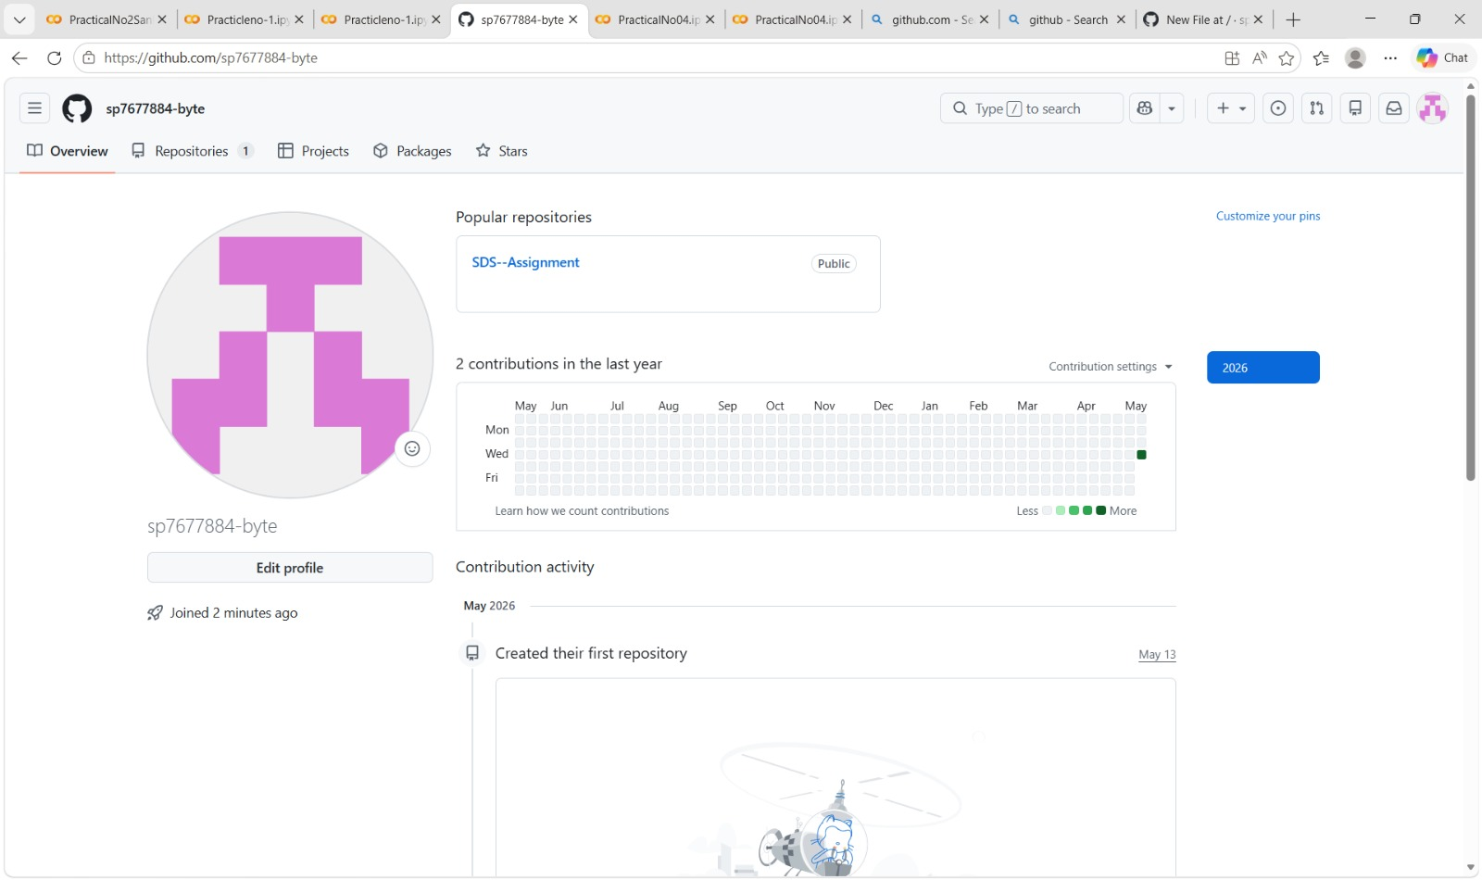
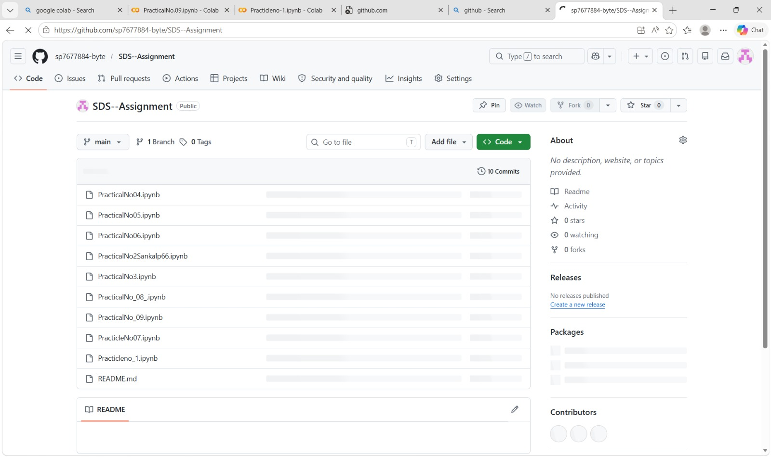

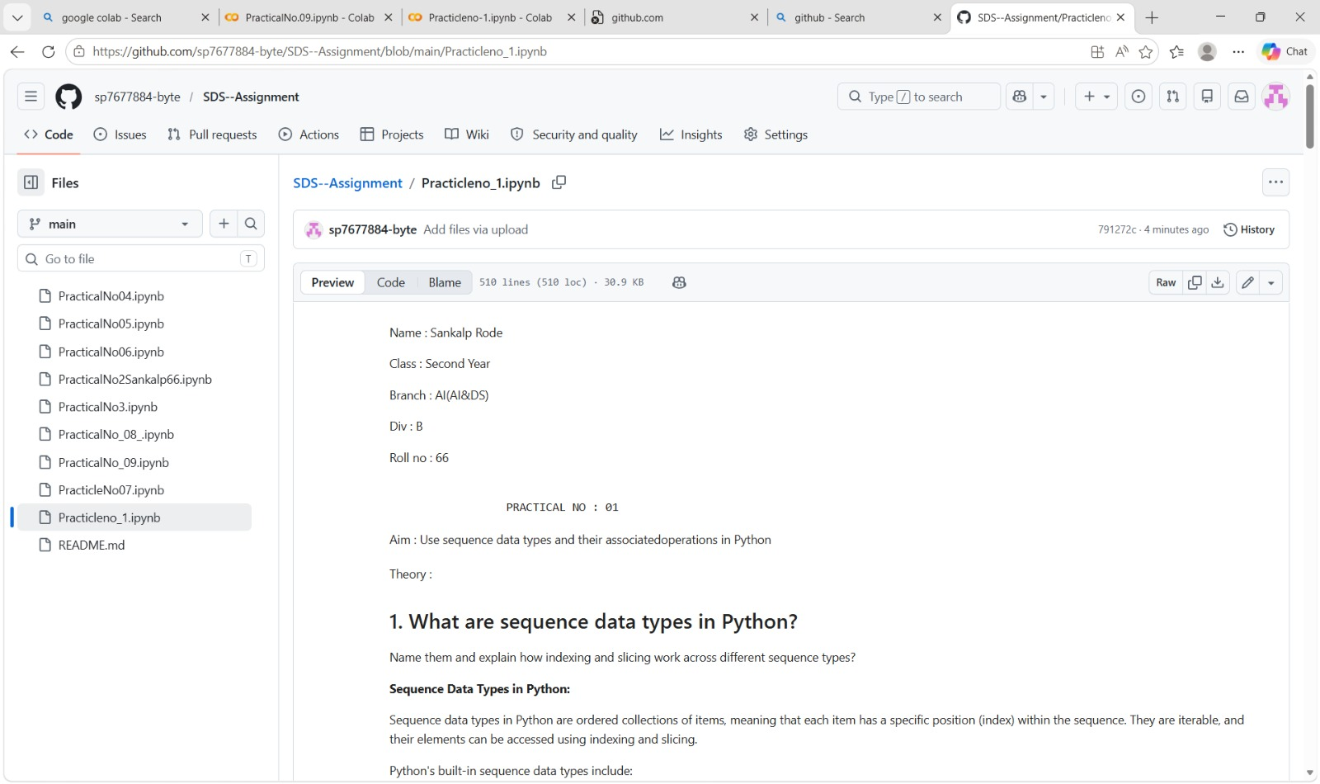

Questions and Answers:
- What is the difference between Git and GitHub? Git is a distributed version control system used to track changes in files and manage project versions locally on a computer. It allows developers to work on code, maintain history, and revert changes when needed. On the other hand, GitHub is a cloud-based platform that hosts Git repositories online and provides additional features like collaboration, sharing, issue tracking, and project management. In simple terms, Git is a tool, while GitHub is a service that uses Git.
- Explain the difference between git add and git commit The git add command is used to move changes from the working directory to the staging area, meaning it prepares the files to be committed. It does not save the changes permanently. The git commit command, however, records the staged changes into the repository along with a message describing the update. In short, git add selects the changes, while git commit saves them permanently.
- What is the staging area in Git? The staging area in Git is an intermediate space where changes are stored before they are committed to the repository. It allows users to review and organize changes by selecting which files or parts of files should be included in the next commit. This helps in maintaining clean and meaningful commit history by avoiding unnecessary or incomplete changes.
- What happens if you modify a file after committing it? If a file is modified after it has been committed, Git recognizes it as a new change and marks it as modified in the working directory. The previous committed version remains unchanged in the repository. To save the new changes, the user must again add the file to the staging area using git add and then commit it using git commit.
- Difference between git push and git pull The git push command is used to upload local repository changes to a remote repository such as GitHub, making them available to others. In contrast, the git pull command is used to fetch and download changes from the remote repository and merge them into the local repository. Essentially, git push sends data from local to remote, while git pull brings updates from remote to local. 6.What is Version Control? Differentiate between Centralized and Distributed VCS Version Control is a system that helps track and manage changes to files over time, allowing users to maintain different versions, collaborate with others, and revert to previous states if needed. In a Centralized Version Control System (CVCS), there is a single central server that stores all versions of files, and users must connect to this server to access or modify data. In contrast, a Distributed Version Control System (DVCS), such as Git, allows every user to have a complete copy of the repository, including its full history. This makes DVCS more flexible, faster, and capable of working

